Buying A Used Car In A Bull's market: Can Data Science Help?
Juan Villegas
MAT 342 Explorations in Data Science
January 9th, 2022

Table of Contents
Table of Contents 2
Introduction: 3
Data Exploration: 3
How Graphical Displays Will Be Introduced: 5
Year Graphical Displays 6
Fuel Type Graphical Displays 8
Make Graphical Displays 9
Transmission Graphical Displays 10
Total Range Graphical Displays 11
Engine Size Graphical Displays 13
Mileage Graphical Displays 15
Conclusion from Graphical Displays 16
Preparing to Model Data 16
Data Partitioning 17
Why 17
Validation: 17
Chi-squared test for our 7 predictor variables. 18
Baseline & Accuracy of Model (Training) 19
Baseline & Accuracy of Model (Testing) 20
Cart Models 21
10-fold Cross validation 21
Final Cart Model 22
Final CART Model comparisons to baseline and foreign data (Test data) 23
Conclusion 23
Evaluating Our Model 24
Accuracy and Overall error rate 24
Sensitivity and Specificity 24
False Positive Rate and False Negative Rate 25
Proportion of True Positive, Proportion of True Negative, Proportion of False Positive, Proportion of False Negative 25
Full interpretation of our model 26

Introduction:
This Data Science report will be conducted on a data set that includes 100,000 listings of used cars. The data set contains variables like: USD price, transmission, mileage, fuel type, total driving range, engine size, ect... The data set was cleaned & manipulated so that duplicate listings were removed and so that the csv file would appropriately function in R. The goal of this report is to learn about the used cars market (before it became bull/the prices increased) to see what variables contribute to a car costing less. I will use my budget (target variable) of 15k to find these variables. The data used in this report is from Kaggle, 100K UK Used Car.

Data Exploration:
The 100k UK Used Car data set has 8 variables that can be explored and overlayed to my budget of 15k. The 7 explanatory variables we will be looking at is:
- Engine Size
- Year
- Mileage
- Transmission
- Make
- Fuel Type
- Total Driving Range
I will first create histograms and bar plots of our explanatory variables to see what we’re working with
*Regular outliers are calculated: Q1 - 1.5*IQR (Lower Fence) & Q3 + 1.5*IQR (Upper Fence)

*Extreme outliers are calculated: Q1 - 3*IQR (Lower Fence) & Q3 + 3*IQR (Upper Fence)

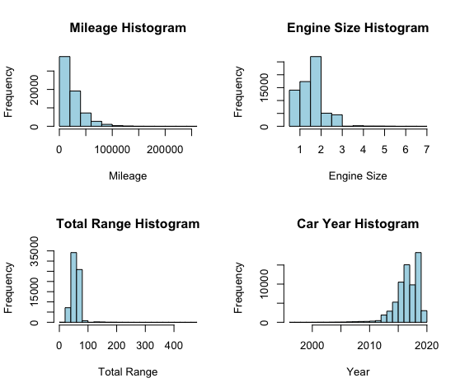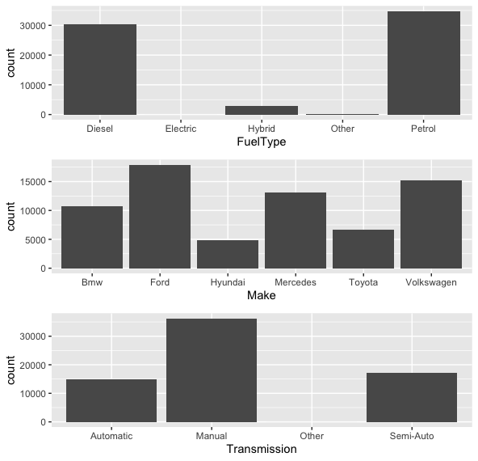
Figure 0. Figure 0 demonstrates 4 histograms and 3bar plots for the explanatory variables in this report.
Looking at these histograms we can understand more about the data we’re using. It is noticeable that most of the cars in this data set tend to have fewer mileage. The most common engine size is between 0-2. Most of these cars in this data set get less than 100 for their total range. A huge proportion of cars in this dataset are from 2010 or newer.
The boxplots also tell us a lot about our data. Most of the cars in this dataset run on either petrol or Diesel. Toyota and Hyundai have the least amount of listing in this data set. The most common transmission from this data set is Manual.

How Graphical Displays Will Be Introduced:
We will continue to visualize more in depthly the 7 predictor variables that we introduced: Fuel Type, Make, transmission, Year, Total Range, Engine Size and Mileage. The visualizations will be displayed in this order:
1st: some predictor variables will have scatterplots, others won’t.
2nd: A bar chart or histogram will be displayed for the variable showing the bars in Dodged position.
3rd: A bar chart or histogram will be displayed for the variable showing the bars in stacked position
3rd: A bar chart or histogram will be displayed for the variable showing the bars in filled position
4th: Some predictor variables will receive a binned version of bar charts

Year Graphical Displays
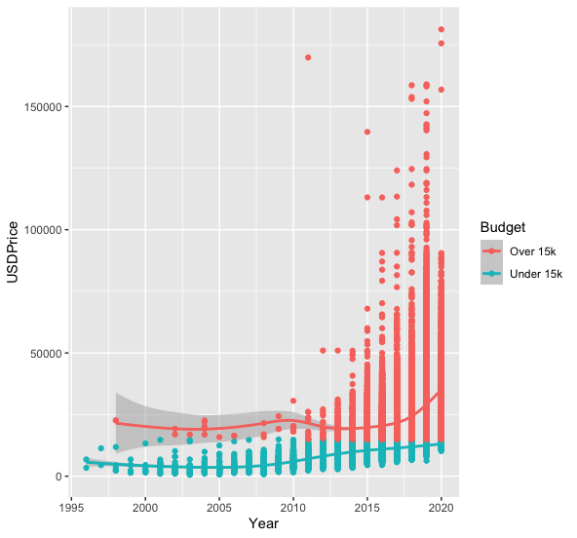
Figure 2. Figure 2 shows a scatterplot that is distributed by the year with an overlay of our budget.
Figure 2 shows an obvious pattern that as a car is older in age, the price is less.
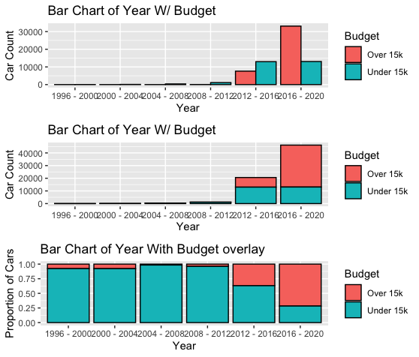
In the beginning of this report, when Year was introduced as a continuous variable. To make this the graphical displays easier to see (so we wouldn’t have to see a bunch of little bars for a histogram), I decided to bin our year predictor variable into 6 groups. 1996 – 2000, 2000 – 2004, 2004 – 2008, 2008 – 2012, 2012-2016, and 2016-2020.

Figure 3. Figure 3 shows bar charts of year with an overlay of our budget. The year variable has been binned into 6 categories from 1996 – 2020.
Looking at figure 3’s 1st and 2nd graph hard to tell how the car count for the years 1996 – 2012. We had to blow up the graph into the proportions of the amount of cars for the overlay to see that from the years 1996 – 2015, the proportion of cars that cost under our budget of $15k is high. Once the year range is between 2016-2020, the proportion of cars over our budget is now the majority.
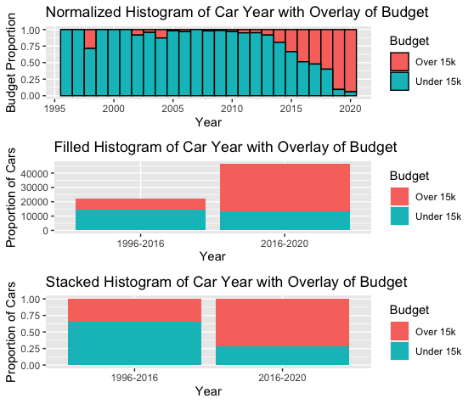
Figure 4. Figure 4 shows an even more binned histogram of year with an overlay of our budget. The year variable has been binned so that we can see when the proportion of cars costing less than 15k is more than .5.
Looking at figure 4’s 1st graph ,it is inferred that most cars before the year 2015 are less than 15k. The 2nd graph, obviously shows that most of the cars built between 2016-2020 are more than 15k. Examining the binned histogram with proportions, we can easily distinguish that between the 1996 – 2015, almost 75% of the cars in this dataset cost less than 15k while, almost 75% of the cars built in 2016 and after are more than 15k.

Fuel Type Graphical Displays
Figure 5. Figure 5 shows 3 Fuel Type bar charts overlayed with of our budget. The 1st barc hart has its boxes in a dodged position, the 2nd in a stacked position, lastly, the 3rd box chart’s boxes are in a filled position 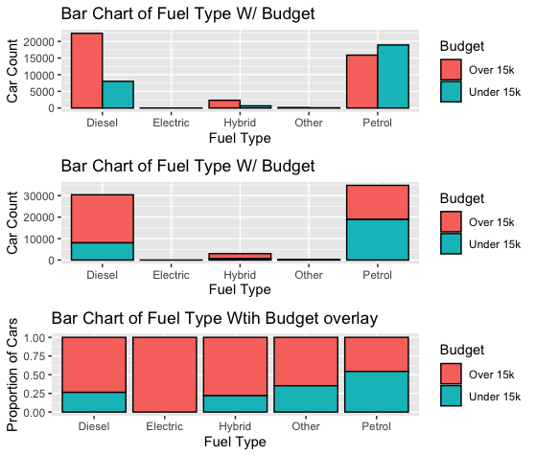
Figure 5 shows us that the cars that run on petrol tend to be less expensive than the other fuel types. is Petrol. Electric vehicles have no car costing less than $15,000. Hybrid vehicles also have a small proportion (20%) of cars costing less than $15,000. 1 in 4 cars from this data set cost less than $15,000 if they run on Diesel fuel.

Make Graphical Displays
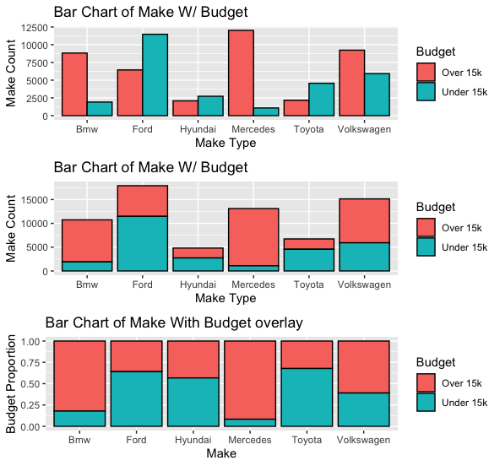
Figure 6. Figure 6 shows 3 bar charts of Make with an overlay of our budget. The 1st bar chart has its boxes in a dodged position, the 2nd in a stacked position, lastly, the 3rd box chart’s boxes are in a filled position.
Figure 6’s first bar chart is hard to read. There are some teal boxes that are taller than the red and vice versa. When we look at figure 4’s second bar chart. It is easier to comprehend which car makes tend to be over or under our budget of $15k budget. Once we look at the third bar chart. It is a walk in the park to understand the chart. In our data set, the makes that have the highest proportion of under $15k, are Ford Hyundai, and Toyota. Volkswagen is close to our .5 cutoff. Almost 90% of all Mercedes in this data set are over our budget of $15k, so we will be avoiding that brand.

Transmission Graphical Displays
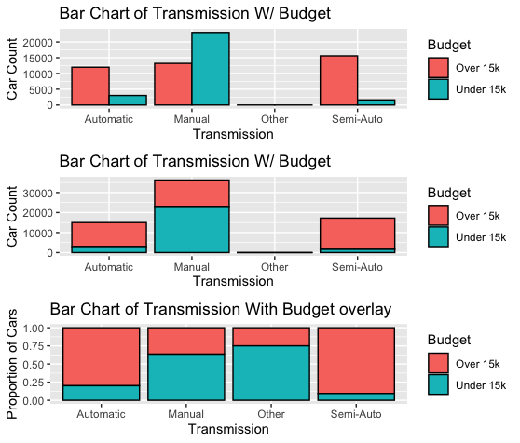
Figure 7. Figure 6 shows 3 bar charts of Transmission with an overlay of our budget. The 1st bar chart has its boxes in a dodged position, the 2nd in a stacked position, lastly, the 3rd box chart’s boxes are in a filled position
Figure 7 shows 3 bar charts of Transmission with different positions of how the bars are placed. The 1st bar chart doesn’t show us a good scale as to how the “Other” category compares to the other types of Transmission. Since we’re talking about the ‘Other’ category, I should explain that for a car to be considered ‘Other’, the transmission must be a ‘Continuously variable transmission’ or CVT. The second bar chart in figure 6 doesn’t show us a better image of the ‘Other’ category neither but, it does clean up the amount of box we have to look at, it makes it cleaner. Finally the third bar chart shows what we want to see, the proportional over of our budget to the transmission type. In this bar chart, we can clearly depict that the transmissions type that have the highest proportion of cars falling in our budget range are: Manual and ‘Other’. What a coincidence: we discovered that ‘other’ transmissions fall within our budget range!

Total Range Graphical Displays
In the beginning of this report, Total range was introduced as a continuous variable. To make this the graphical displays easier to see (so we wouldn’t have to see a bunch of little bars for a histogram), I decided to bin our MPG predictor variable into 6 groups. 1 – 60, 60 – 120, 120 – 180, 180 – 240, 240-300, and then R skips the rest of the bins I made (because we don’t have cars within those ranges) and leaves us with 420-480.
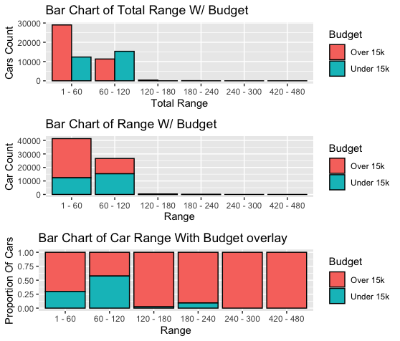
Figure 8. Figure 8 shows 3 bar charts of Range with an overlay of our budget. The 1st bar chart has its boxes in a dodged position, the 2nd in a stacked position, lastly, the 3rd box chart’s boxes are in a filled position
Figure 8 shows a bar chart of the ranges that the cars in our data set has. The first bar chart proves difficult to see how much cars are in the range after the range groups go from 120 - 480. The last bar chart shows us the proportions and blow up everything that we want to see. It is understood that the cars with the range of 60 – 120 have the highest proportions of cars in this data set within our budget range.
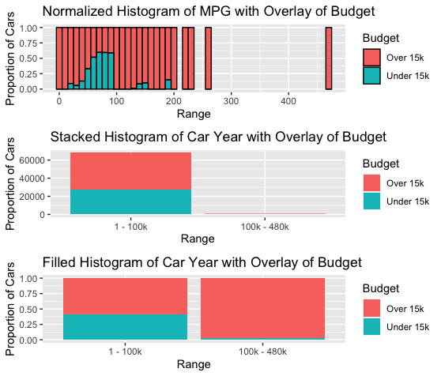
Figure 9. Figure 9 shows an even more binned histogram of range with an overlay of our budget. The range variable has been binned so that we can see when the proportion of cars costing less than 15k is more than .5.
Figure 9 better depicts figure 8. The normalized histogram in figure 9 gives us a better view that between 10-90 in range, the proportion of cars that are under 15k increases. After that, the proportion drops completely and the cars that have ranges over100 tend to be over $15k. the filled histogram with an overlay of our budget shows that almost 50% of the cars in this data set that have a range between 1-100 are within our budget.

Engine Size Graphical Displays
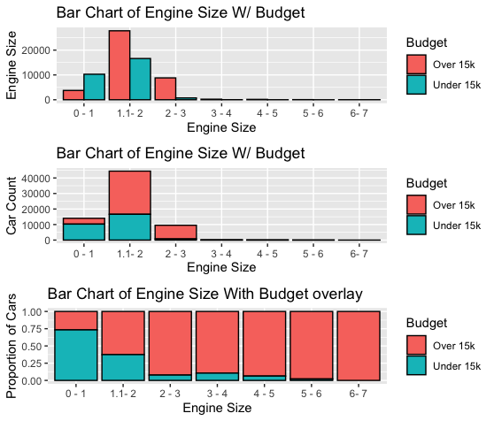
Figure 10. Figure 10 shows 3 bar charts of engine size with an overlay of our budget. The 1st bar chart has its boxes in a dodged position, the 2nd in a stacked position, lastly, the 3rd box chart’s boxes are in a filled position
Figure 10 shows a bar chart of the engine sizes that the cars in our data set have. The first and second bar chart in figure 10 chart proves difficult to see how much cars have engine sizes between 3 – 7. The last bar chart shows us the proportions and blows up everything that we want to see. It is understood that the cars that have between 0 – 2 engines have the highest proportions of cars in this data set within our budget range.
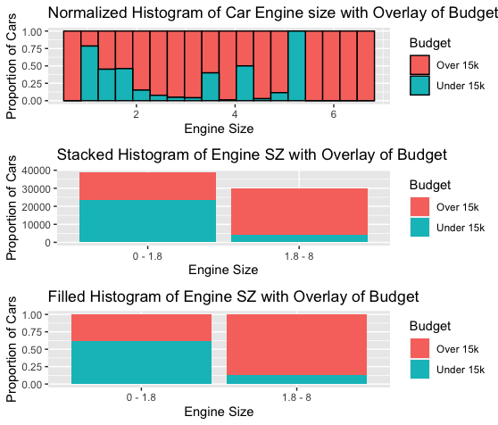
Figure 11. Figure 11 shows an even more binned histogram of engine size with an overlay of our budget. The range variable has been binned so that we can see when the proportion of cars costing less than 15k is more than .5.
Figure 11 better depicts figure 10. The normalized histogram in figure 9 gives us a better view of the proportions of cars that are within our budget. The proportion of cars that are under 15k decreases after the engine size of 0. Almost 75% of the cars with 0 engines are within our budget while almost every other car that has between .5 & 1 engine is in our budget. The proportion rise at 4 and 5 for our engine size but, they can just a low sample size from our data. More than half of the cars with 0 – 1.8 of an engines are within our budget of $15k.

Mileage Graphical Displays
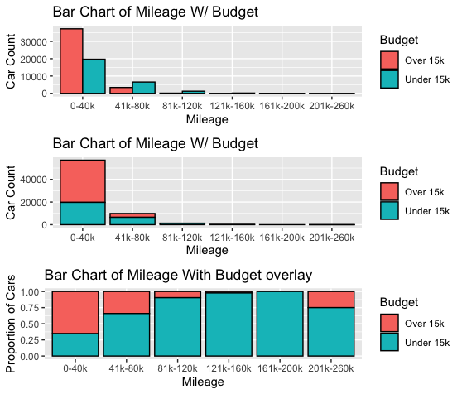
Figure 12. Figure 12 shows 3 bar charts of Mileage with an overlay of our budget. The 1st bar chart has its boxes in a dodged position, the 2nd in a stacked position, lastly, the 3rd box chart’s boxes are in a filled position
Figure 12 shows 3 bar charts of Transmission with different positions of how the bars are placed. Jumping straight to the last bar chart, we can get an understanding of the proportions of cars within our budget in relationship to a car’s mileage. It is easy to notice that as a cars mileage goes up in our data set, the proportion of a car being within our budget increases. Almost 25% of cars are within our budget when there range is 0 - 40k. That proportion more than doubles when a car is between 41k – 80k. This pattern continues up until the 201k mark. For some reason, it looks like 1 out of 4 the potential 4 cars in this data set (I’m taking the .25 proportion) is listed for over $15k with 201-260k mileage.

Conclusion from Graphical Displays
Our graphical displays gave us some predictor variables that yelled, “Hey I have a high proportion of car under 15! Look at me!”. That means that if we wanted to immediately take some predictor variables from the graphical displays we created we’ve and go looking for cars under $15k, we would most likely choose to look at a car with lower mileage, specific make of cars , make sure we look for cars that run on Petrol, look for cars made before the year 2016, and have either a manual or CVT transmission. This can be great information to use but, we can also use a CART Model to pick the variables out for us. Let’s see what AI has to say about the selection of predictor variables we chose.

Preparing to Model Data
Before we can create this CART model, A few things must happen:
- Data Partioning
- Data Validating
- Create a Baseline & Accuracy of the model.

Data Partitioning

Why
Data Partitioning must happen so that we can split our data in two groups: A training and testing group. We do this so that we can have a testing group to compare the results of our training group… So, we can test the accuracy of our training model. 75% of our data will be partitioned into the Training group and 25% of our data will go into the Testing group.

Validation:
When validating variables, you must validate the numeric and categorical variables differently. The numeric (continuous) variables must satisfy 2 conditions to be validated: The training & test boxplots must look similar and Kruskal’s p-values must be greater than 0.1. The validate the categorical variables, all we must do take a chi-squares test and make sure that the p-value is more than .1. Luckily for us, throughout the report, we binned our numeric variables meaning that we transformed them into categorical variables.

Chi-squared test for our 7 predictor variables.
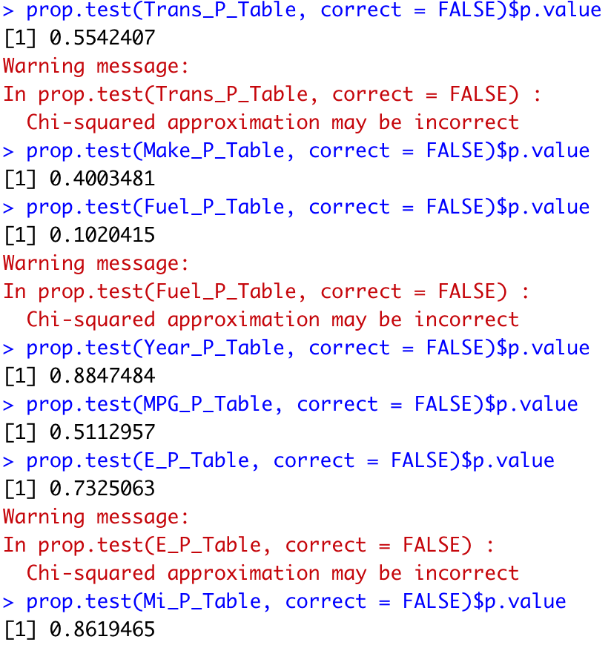

Figure 13. Figure 13 shows chi-squared tests for all our 7 predictor variables: 1. Transmission, 2. Make, 3. Fuel, 4. Year, 5. Range, 6. Engine Size, 7. Mileage.
Figures 13 exemplifies that the 7 predictor variables pass the condition for categorical variables when partitioning the data. The P-Values for all variables range between 0.102 & 0.884 (All higher than 0.1).

Baseline & Accuracy of Model (Training)
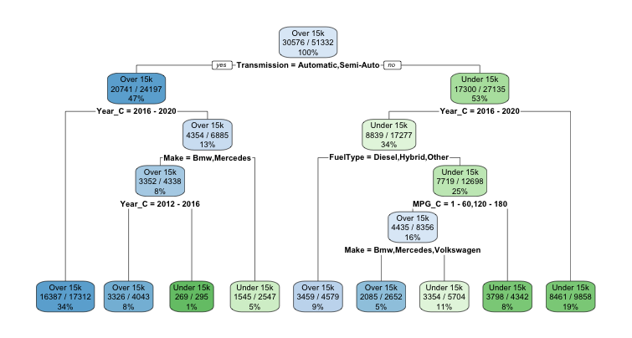
The Baseline model is determined from the 1st node that the CART model makes.
Figure 14. Figure 14 shows the default CART Model for the Training Data that R created.
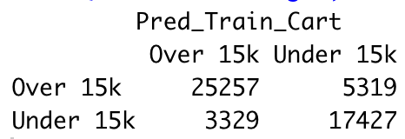
To get the Baseline of this model, look at the first node and the numbers that are being divided. The Baseline model is 0.5956518 (30576/51332) in other words 59.57%, which is not bad. Now, it is crucial to test the accuracy of the CART model. To do this, look at the table (to the right) that shows whether a car is over 15k or under 15k on the prediction of the model. It’s easy to see the cars that were correctly classified as false and true on the training prediction CART model. The Accuracy of this model is 0.8315281 ((25257+17427)/51332) Which is 83.15%. The CART model’s accuracy is 0.395997 ((0.8315281-0.5956518)/(0.5956518)) or 39.6% more than the baseline.

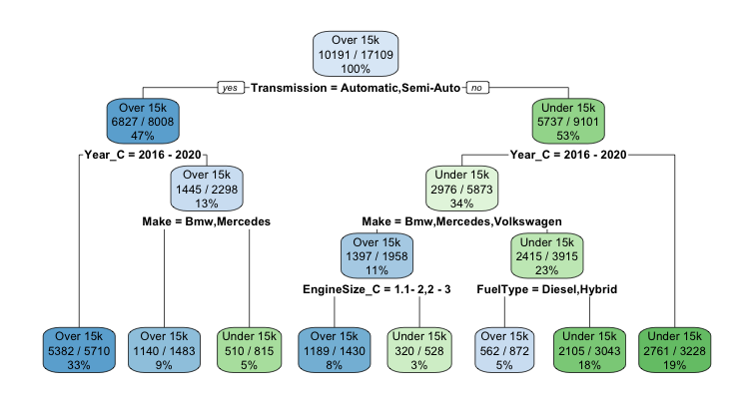
Baseline & Accuracy of Model (Testing)
Figure 15. Figure 15 shows the default CART Model for Testing Data that R created.
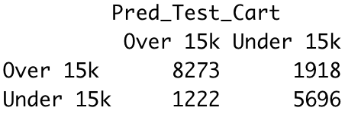
The Baseline model is 0.5956514 (10191/17109) in other words 59.57%. The table of the Testing data (to the right) shows whether a car cost over or under $15k on the prediction of the model (same as the Training table). The Accuracy of this model is 0.8164709 ((8273+ 5696)/(17109)) Which is 81.65%. The CART model’s accuracy is 0.3707194 ((0.8164709 -0.5956514)/(0.5956514)) or 37.07% more than the baseline.

Cart Models
In the Data Partitioning part of this report, we created 2 cart models, training, and test. These CART models gave the baseline and accuracy of the training and test data. Now our focus will be shifted into creating a CART model that gives a balance of accuracy and complexity. To do this, 10-fold cross validation needs to be done. 10-fold cross is a technique where R simultaneously creates CART models and then spits out a Complexity parameter for us to use.

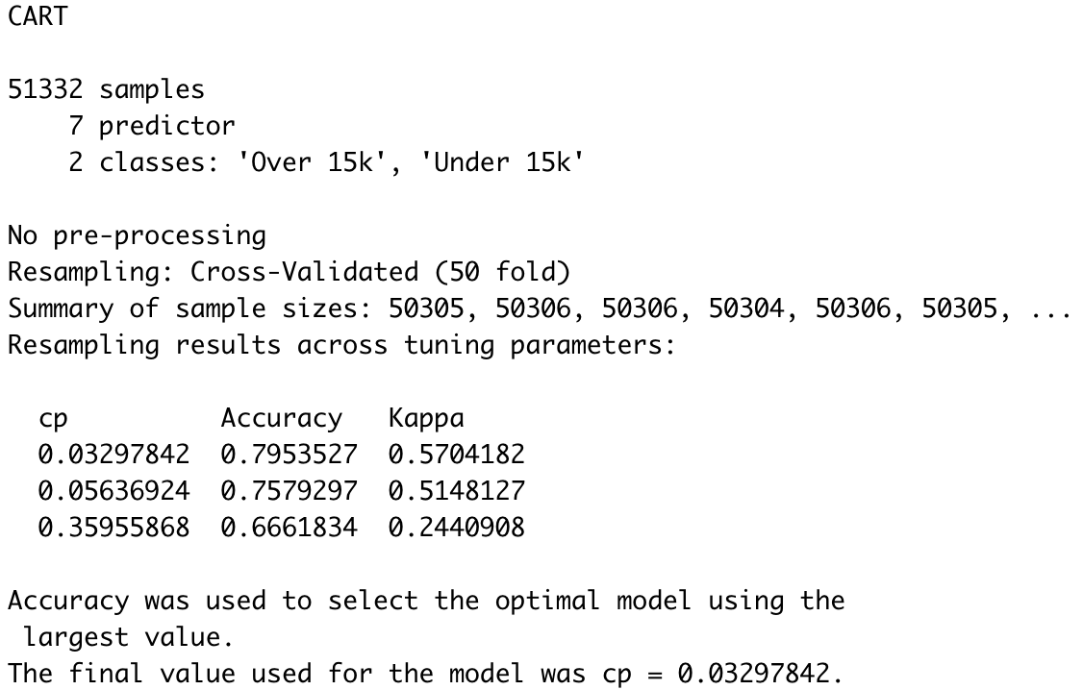
10-fold Cross validation
Figure 16. Figure 16 shows the default CART Model for Testing Data that R created.
Figure 16 gives us R output. R shows that it resampled our data 10 times and the final Complexity Parameter (CP) recommended is 0.0008818342.

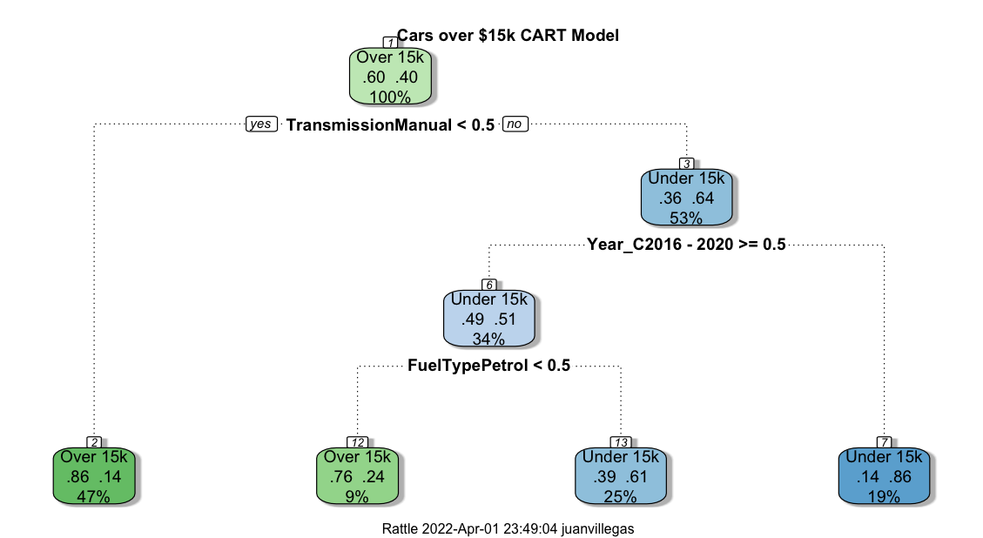
Final Cart Model
Figure 17. Figure 17 shows the Final CART Model

Figure 17 shows the CART model with the most balanced Complexity Parameter. It displays a good balance of complexity and accuracy compared to the last CART model. This CART model is read:
The CART model’s 1st leaf node shows cars costing more than $15k. 60% of the cars in our dataset cost over $15k and 40% cost less than $15k. CART created a branch for cars that are Manual Transmission. If a car is not manual transmission, then CART creates another leaf nodes that indicates: 86% of the cars that are not manual transmission are over $15k. If a car does have manual transmission, then 64% of the cars are under $15k… this is also 53% of the cars in our data set. Another branch is created for whether a car is built before 2016 or during the years 2016-2020. If a car was built before 2016 and is manual transmission then, 86% of these cars cost less than $15k, this node accounts for 19% of our data. Another (and the last) branch is introduced: whether a car runs on petrol or not. If a car runs on petrol, is manual transmission, and built between 2016 and 2020, then 61% of those cars cost less than $15k… that is 25% of the cars in our data set. If a car does not run-on petrol, is manual transmission, and built between 2016 and 2020, then 76% of those cars cost more than $15k… this accounts for 9% of our data set.

Final CART Model comparisons to baseline and foreign data (Test data)
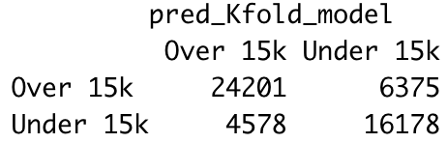
The baseline model of the final cart model is .60, or 60% (as shown in the first node). The accuracy of my CART is 0.7866243 (24201+16178 = 40379 40379/51332) or 78.66%. The CART model’s accuracy is 0.3110405 ((0.7866243-.6)/(.6)) or 31.11% more than the baseline model.
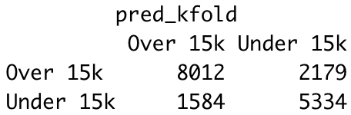
Now testing the Final CART model for accuracy against foreign (our testing data) data, we get 0.7800573 (8012+5334 13346/17109) or 78.01%. The CART model’s accuracy is 0.3000955 ((0.7800573-.6)/(.6)) or 30% more than the baseline model.

Conclusion
From this report, I was able to guess some of the predictor variables that would be included in my CART model by looking at and analyzing the graphical displays that I made. The predictor variables that I should look for when buying a car this winter involve cars that: are Manual for their transmission, where built before the year 2016, and who run on petrol fuel.

Evaluating Our Model
To evaluate our model, we must use our training data set & model it against foreign data (our testing data). We will then create a contingency table of Actual VS Predicted values that our Model created. After that we will see the Accuracy, Sensitivity and Specificity of our model.
Actual | Predicted
 | Over 15K (Negative) | Under 15K (Positive) | Total
Over 15K (Negative) | 8012 (TN) | 2179 (FP) | 10191
Under 15K (Positive) | 1584 (FN) | 5334 (TP) | 6918
Total | 9596 | 7513 | 17109
Table 1 Shows the Actual vs Predicted Values of C5.0 Model for our customers that Churn

Accuracy and Overall error rate
Accuracy = (TN + TP)/ Overall Total = (8012 + 5334) / 17109 = .78005728
Error Rate = 1 – Accuracy = 1 - .78005728 = 0.21994272
Our model correctly classifies whether a car is under or over $15k 78% of the time, and incorrectly cars being over or under $15k 22% of the time.

Sensitivity and Specificity
Sensitivity = TP / (TP + FN) = 5334/6918 = .77103209
Our Model found 77.1% of all cars under $15k.
Specify = TN / (TN + FP) = 8012/10191 = 0.78618389
Our model found 78.62% of all cars that cost more than $15k.

False Positive Rate and False Negative Rate
FPR = 1 – Specificity = 1 – 0.78618389= 0.21381611
Our model incorrectly identified cars costing more than $15k as costing less than $15k 21.4% of the time.
FNR = 1 – Sensitivity = 1- 0.19685039 = 0.22896791
Our model incorrectly identified cars costing less than $15k as costing more than $15k 22.9% of the time.

Proportion of True Positive, Proportion of True Negative, Proportion of False Positive, Proportion of False Negative
PTP = TP / (TP + FP) = 5334/7513 = 0.7099694
Out of all cars classified as less than $15k 71% of them are correctly classified.
PTN = TN / (TN + FN) = 8012 / 9596 = 0.8349312
Out of all cars classified as more than $15k 83.5% of them are correctly classified.
PFP = 1 – PTP = 1 - 0.7099694= 0.2900306
Out of all cars classified as less than $15k 29% of them are incorrectly classified.
PFN = 1 – PTN = 1 – 0.8349312= 0.1650688
Out of all cars classified as more than $15k 16.51% of them are incorrectly classified.

Full interpretation of our model
Overall, our model correctly classifies whether a car is under or over $15k 78% of the time. However, out of all the cars classified as less than $15k the model incorrectly classified 29% of them. Whereas all the cars classified as more than $15k, 83.5% of them are correctly classified.
Our model incorrectly identified cars costing less than $15k as costing more than $15k 22.9% of the time. On the other hand, the model incorrectly identified cars costing more than $15k as costing less than $15k 21.4% of the time.

